Manufacturing Prototype

Team 1253

Athens, Georgia, 2026

Table Of Contents:

Table Of Contents: 2
Research into existing solutions to the problem with photographs 3
Brainstorming, sketching of possible solutions 4
Isometric Assembly Drawing 5
Detailed Drawing 6-7
Photog 7
Bill of Materials 8
Work Log 9

Research into existing solutions to the problem with photographs
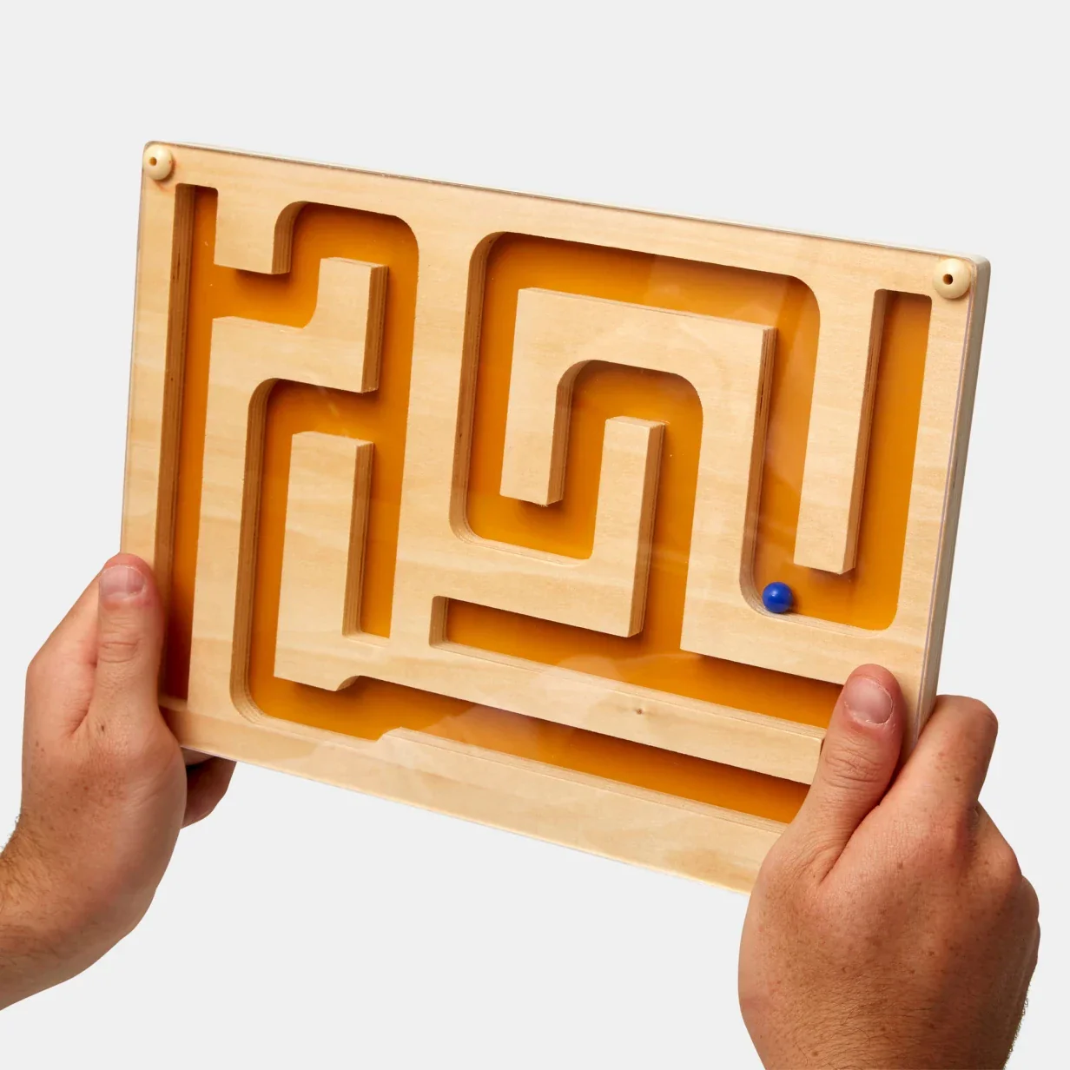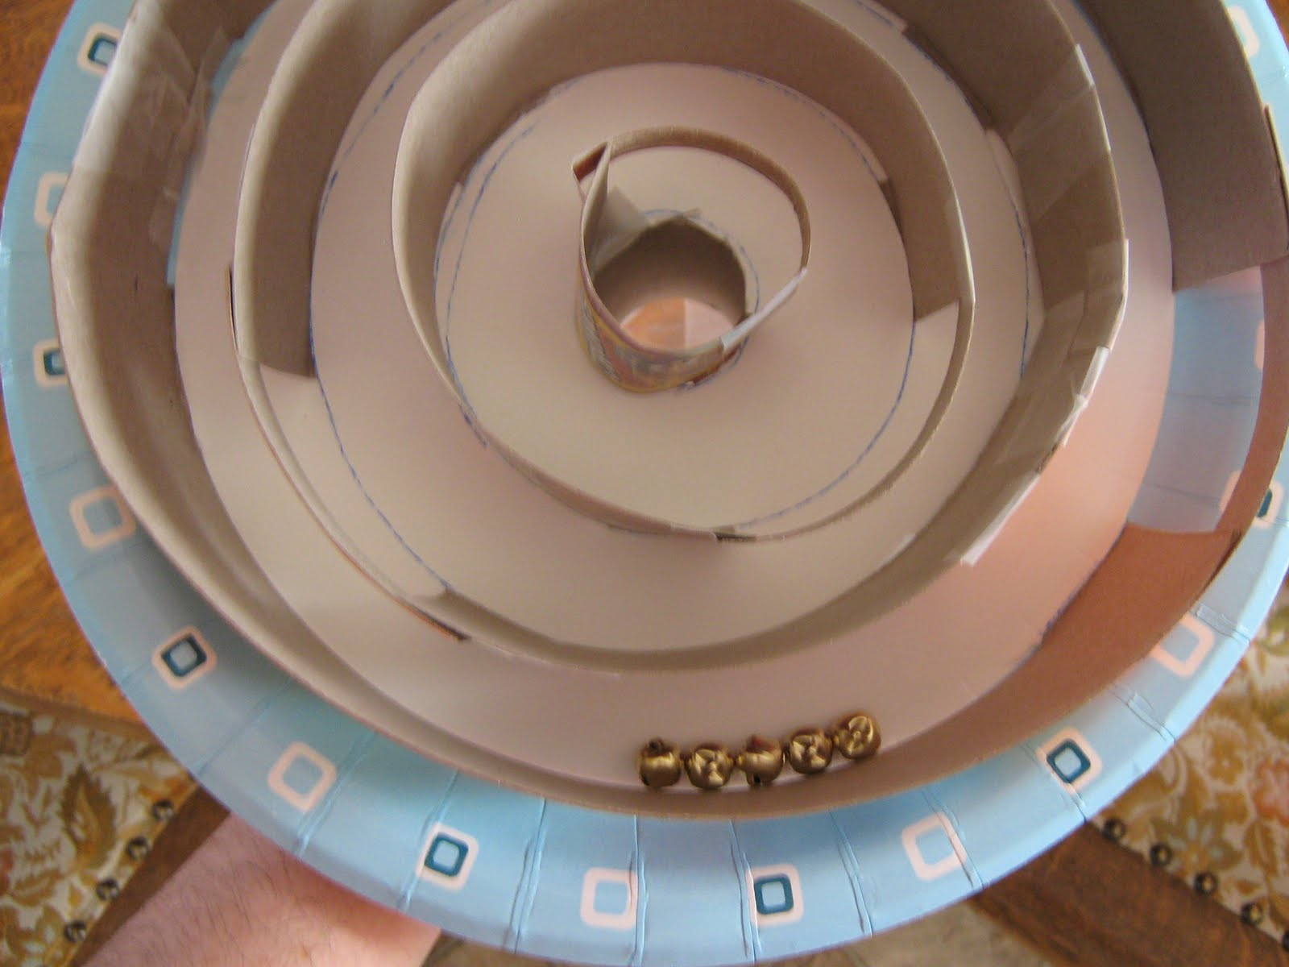
Our focus: We aim to create a puzzle mechanism that incorporates problem-solving, critical thinking, and challenging mechanics, making our maze more engaging while also showcasing a design worth sharing.
Problems in the images:
- There is a lack of instructions, while also not explaining how to solve the goal of the maze, and the design has to show some reasoning behind how it was made.
- There are no perfect measurements on the second image, making it less appealing; it is also apparent that the size of the puzzle is unclear, which makesdifficulthardcreatemake a perfect design.
- There’s no depth to any of these mazes, limiting the entertainment value of these mazes.

Historical mazes:
- The use of mazes from a historical standpoint varied from ancient, complex structures linked to myths, such as Crete’s Minotaur labyrinth, and ritualistic Roman mosaics to medieval church floor patterns and Renaissance hedge mazes for aristocratic games, evolving into turf mazes and elaborate garden puzzles.

What mazes can be used in research:
- The mazes have been used for years now, and normally they are used for behavioral psychology using animals such as rats for the maze trials to study spatial learning, memory, anxiety, and cognition.
- Researchers use mazes to understand how conditions like disease, drugs, or environmental changes affect brain function and behavior in both animals and humans.

The design is going to be used for many different reasons, such as game design or educational uses:
- The mazes can be used to teach children about problem-solving and critical thinking.
- The educational prospect of this is very important for the development of spatial reasoning that is not normally taught in schools.

Solutions:
Our prototype can be used to develop crucial skills like fine motor control, hand-eye coordination, problem-solving, and cognitive function in children. Simultaneously, it offers fun, focus, patience, and imaginative play.

Brainstorming and sketching of possible solutions
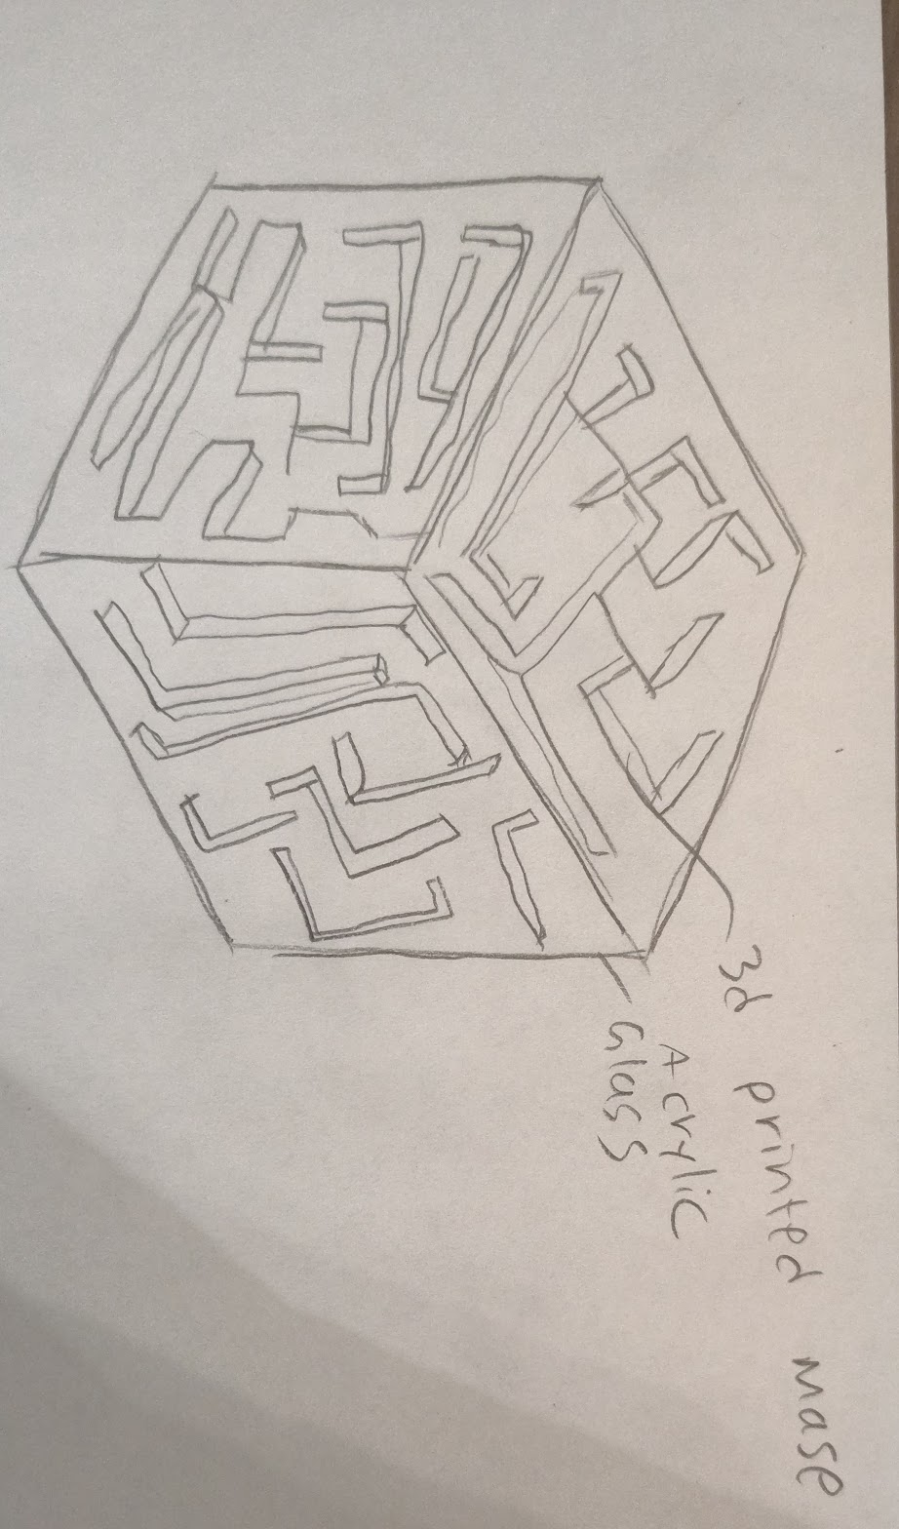
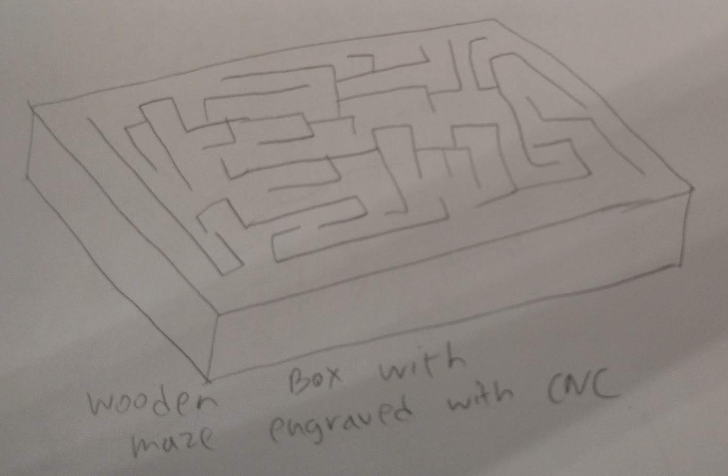
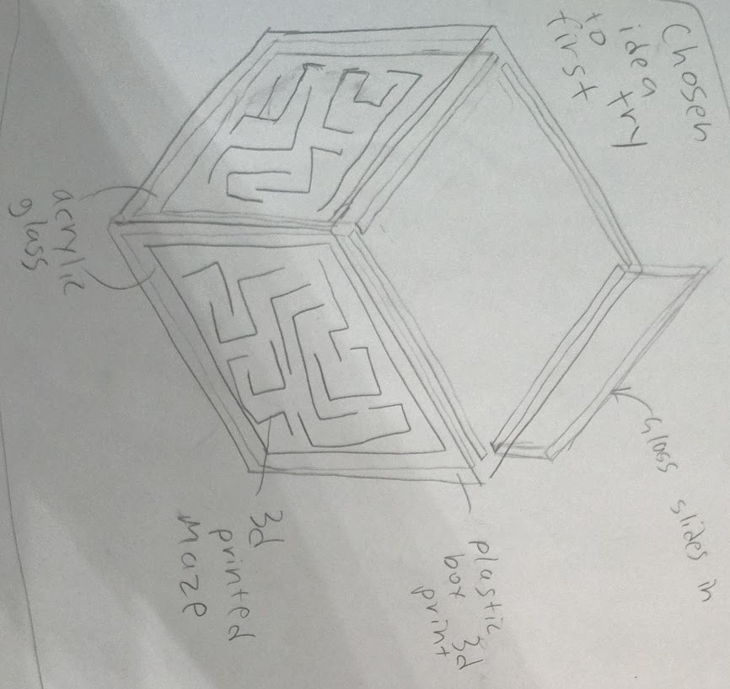
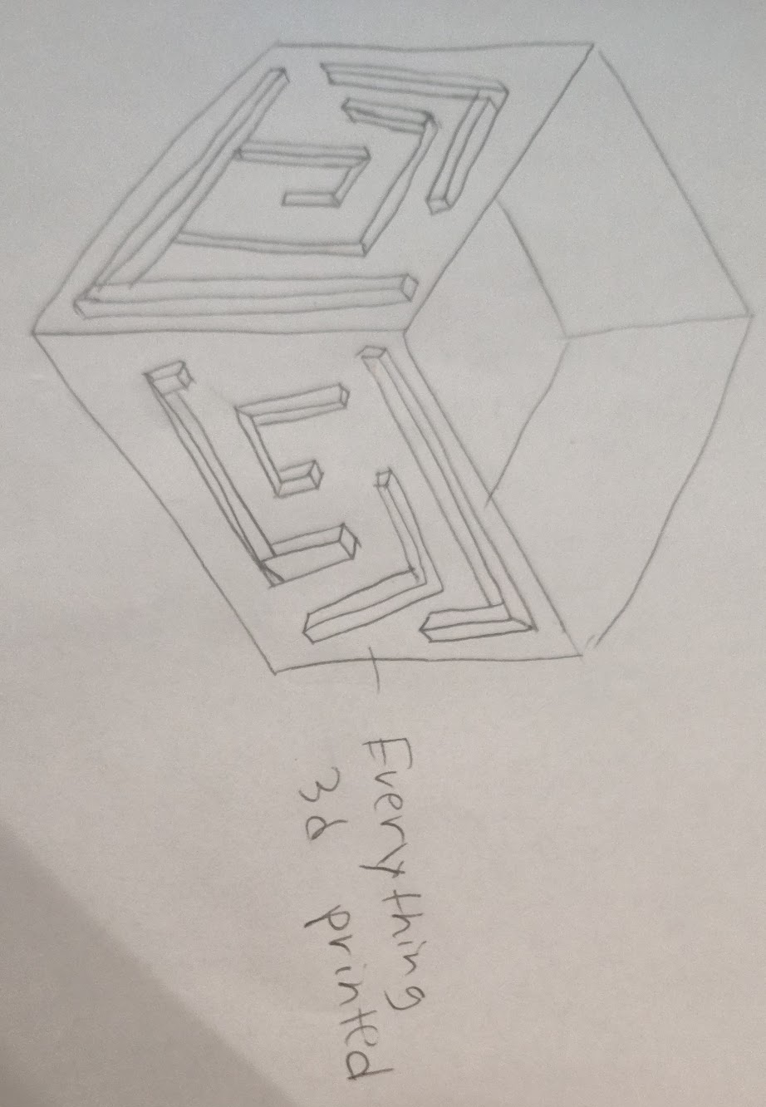
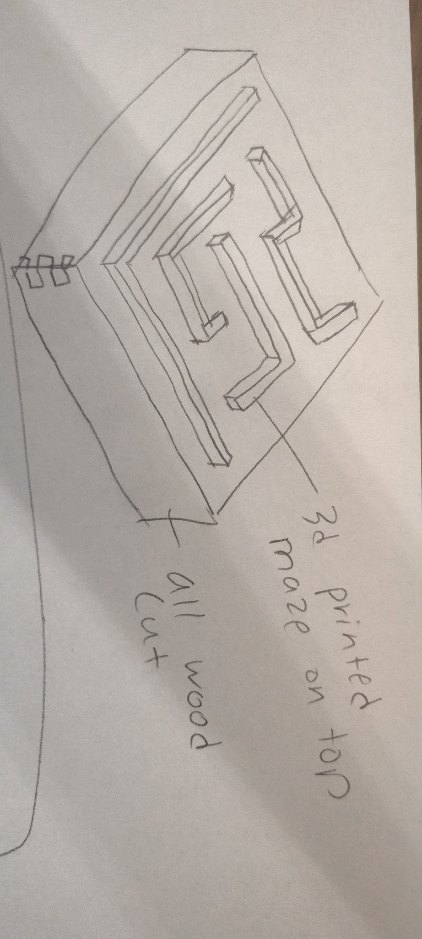
D

Isometric Assembly Drawing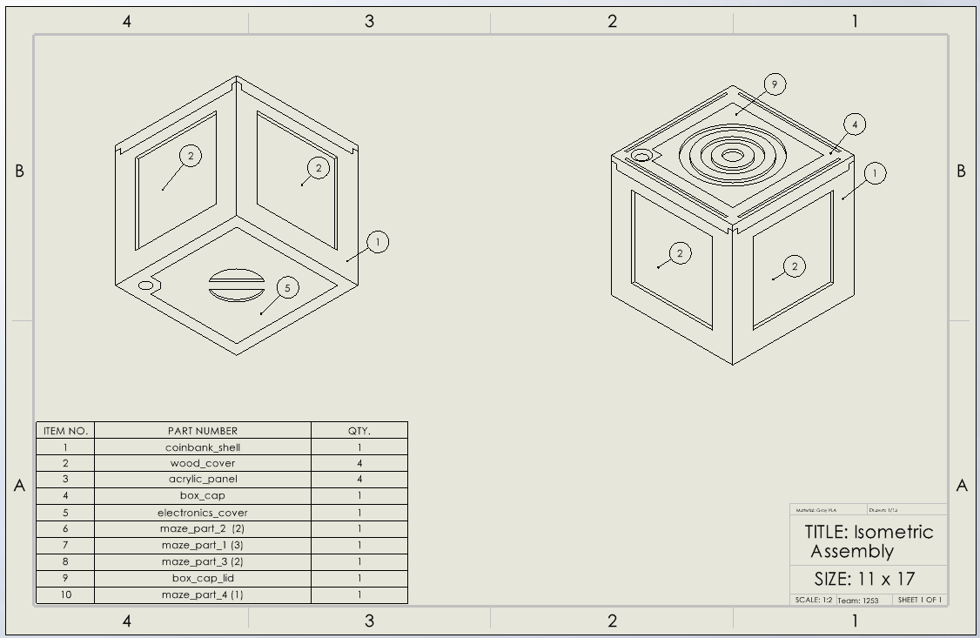

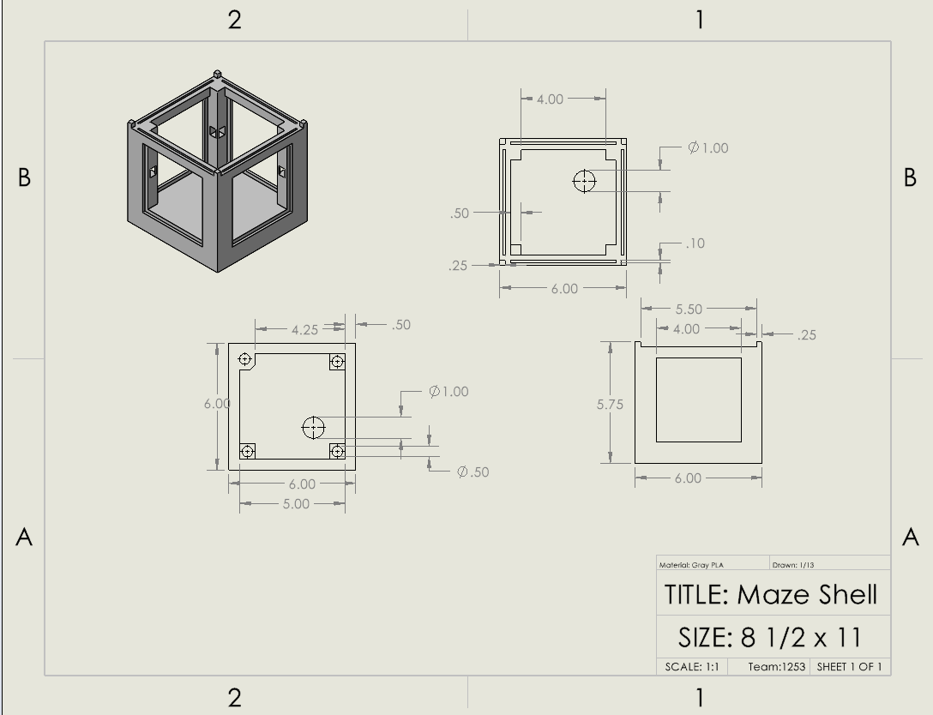
Detailed Drawings [next page]
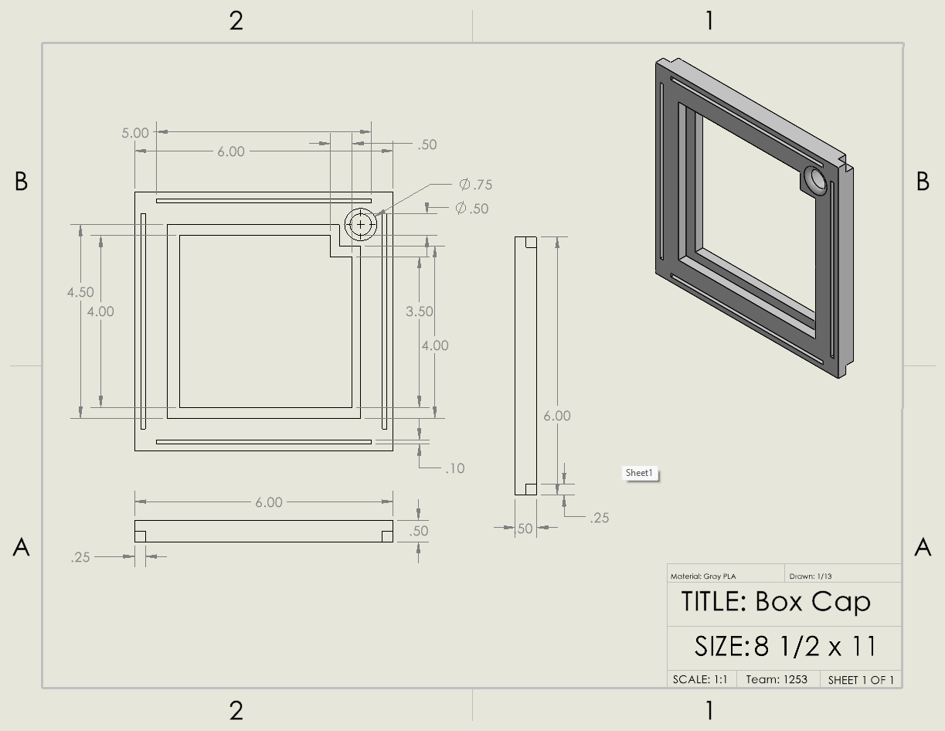
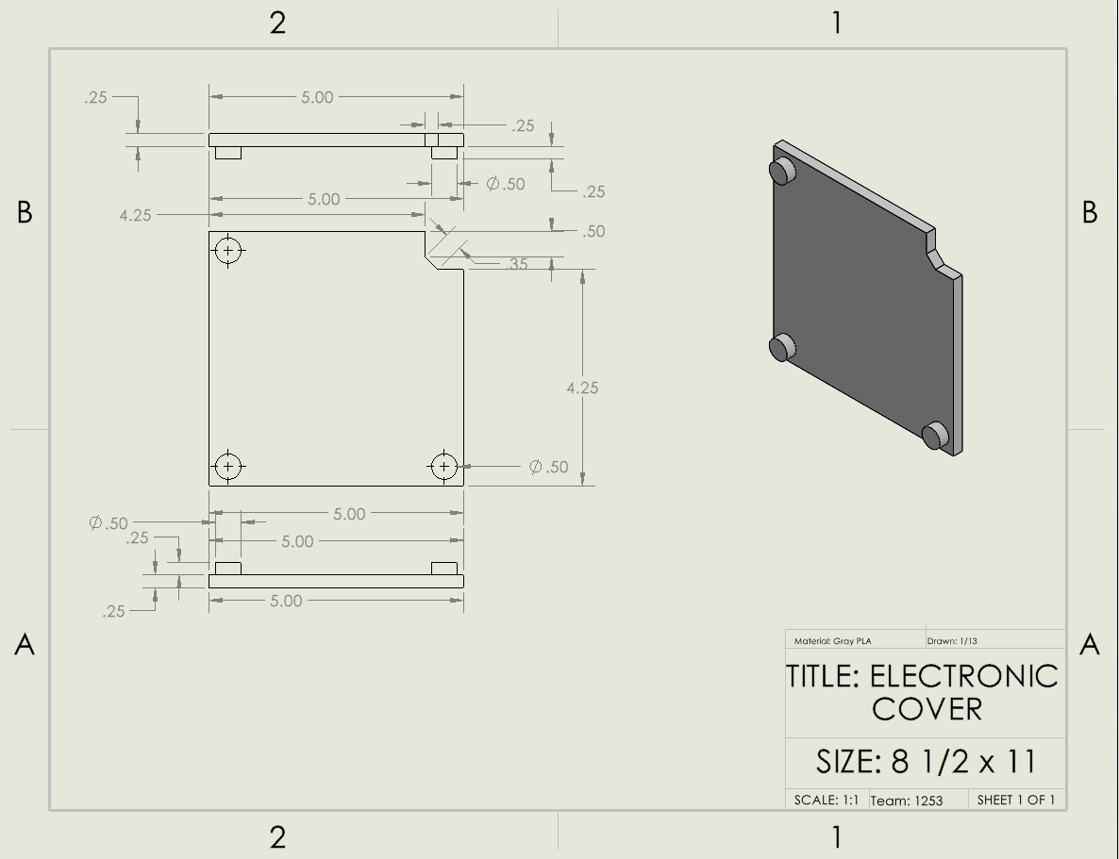
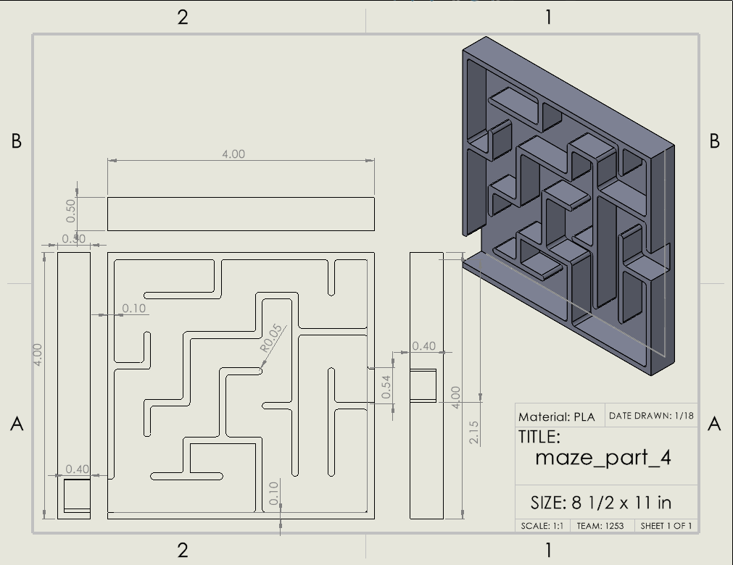
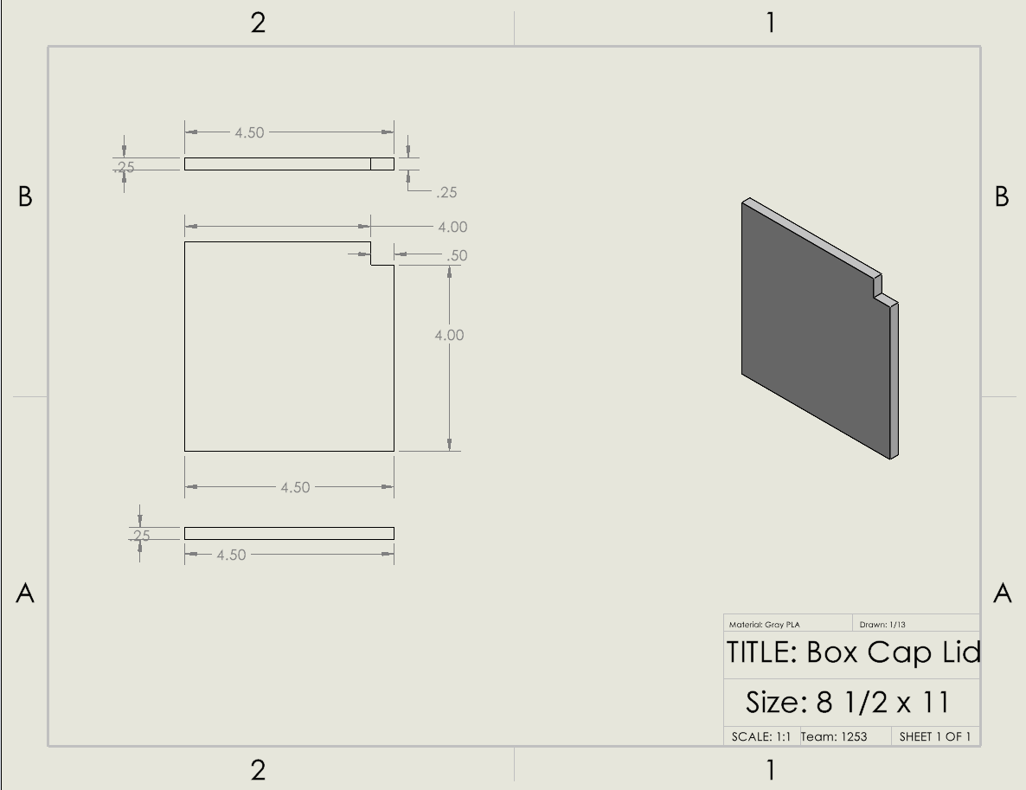
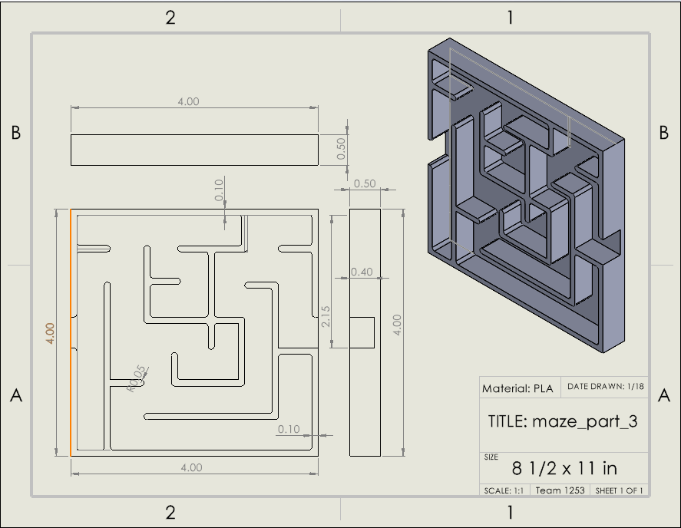
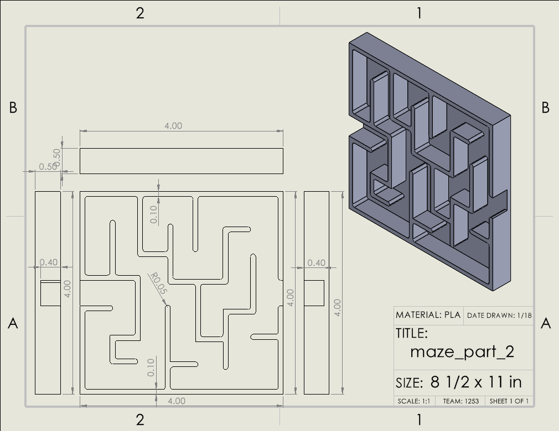
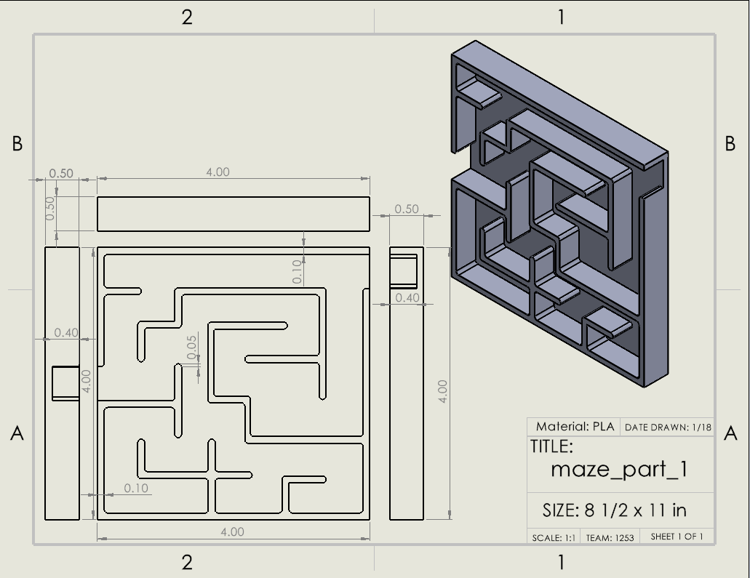

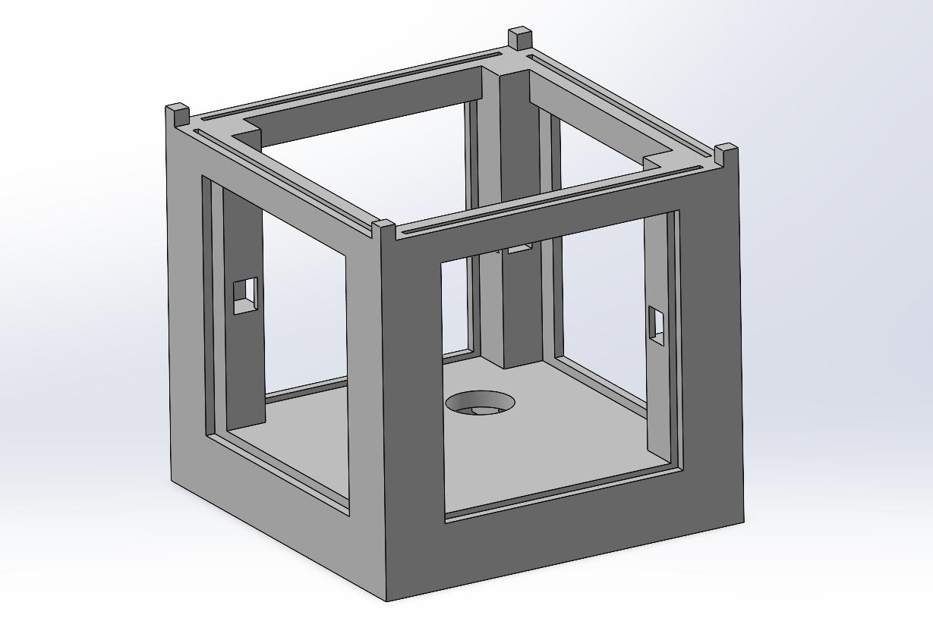
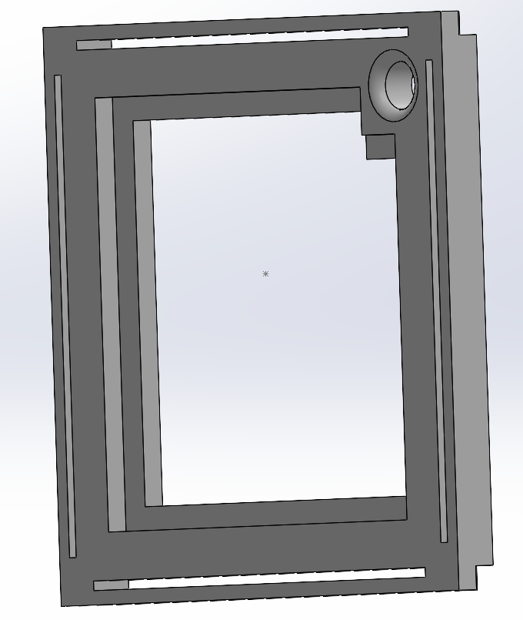
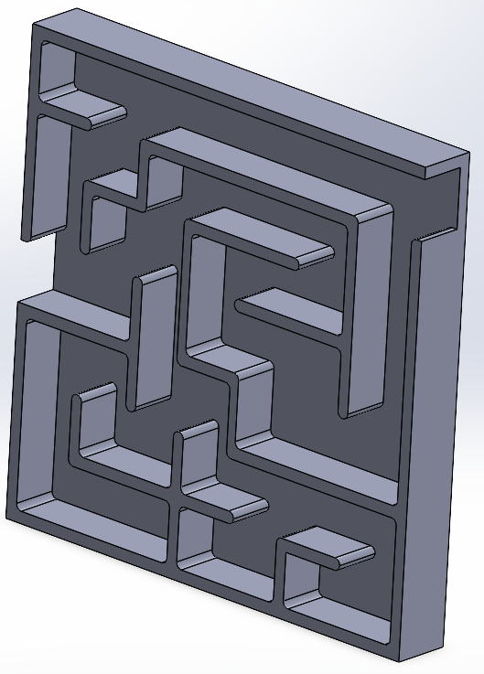
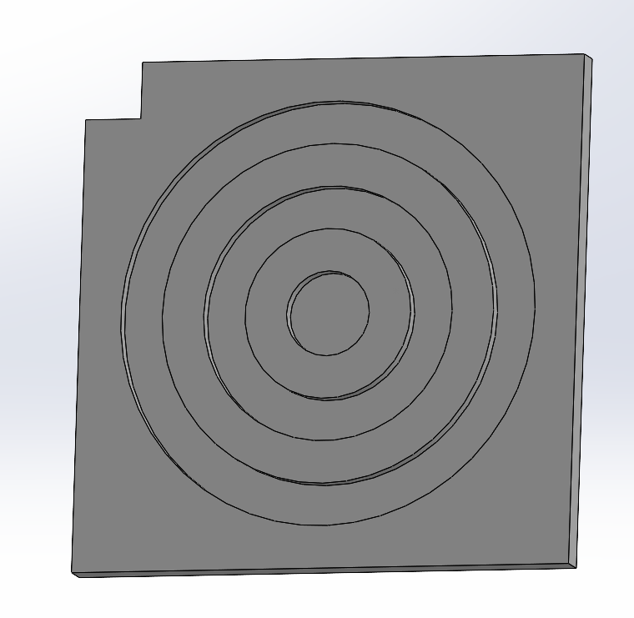
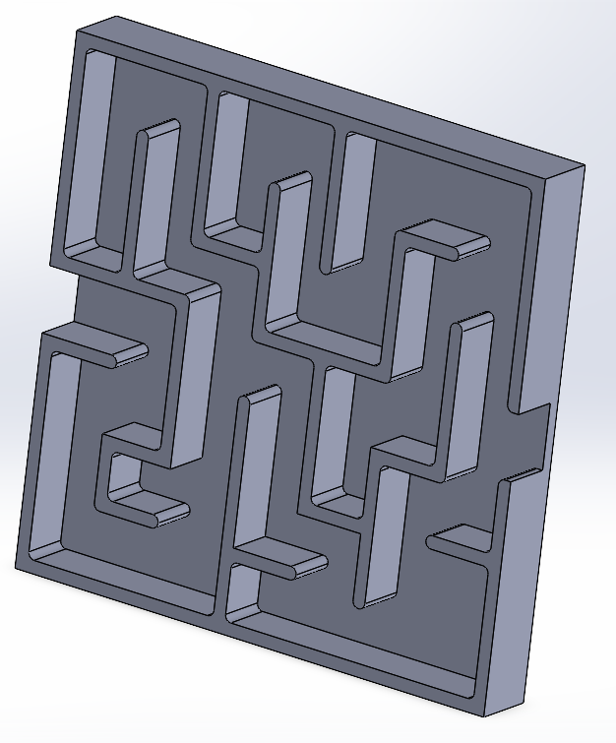
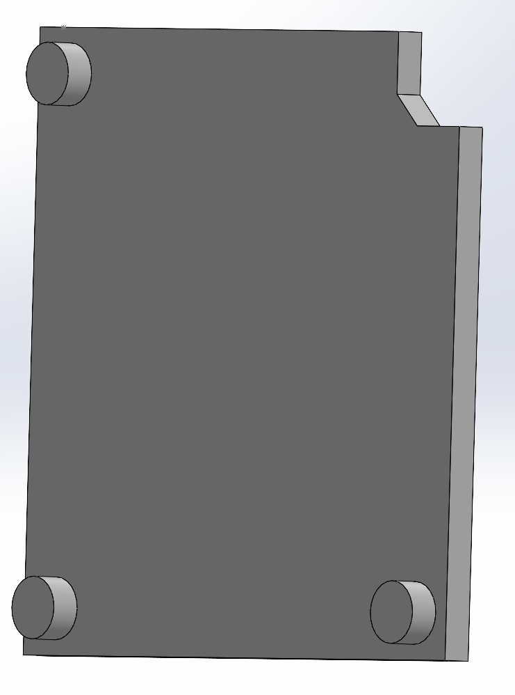
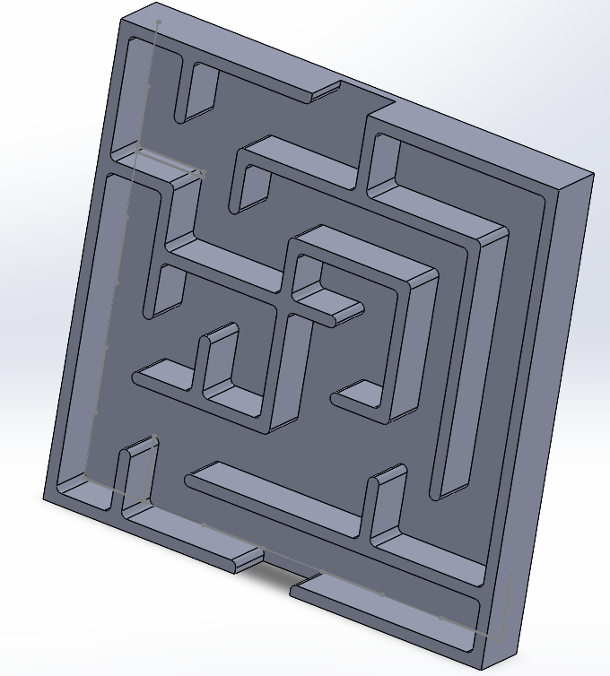
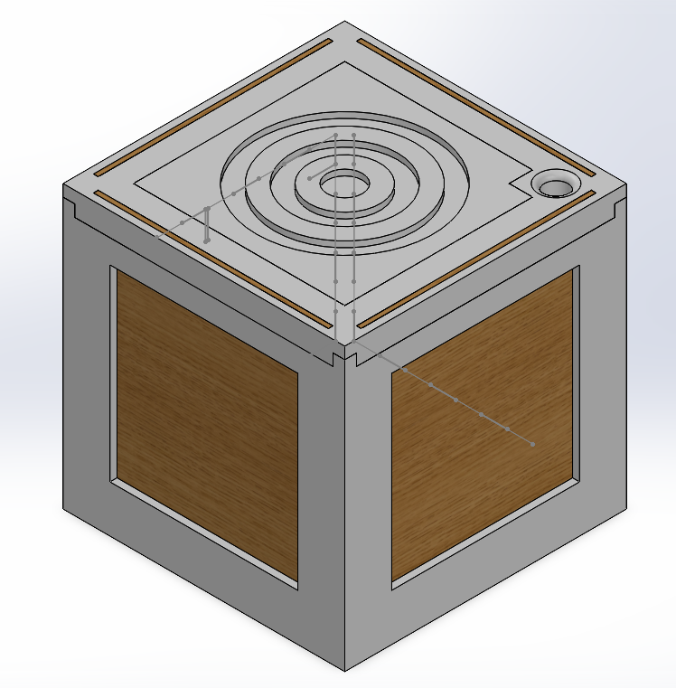
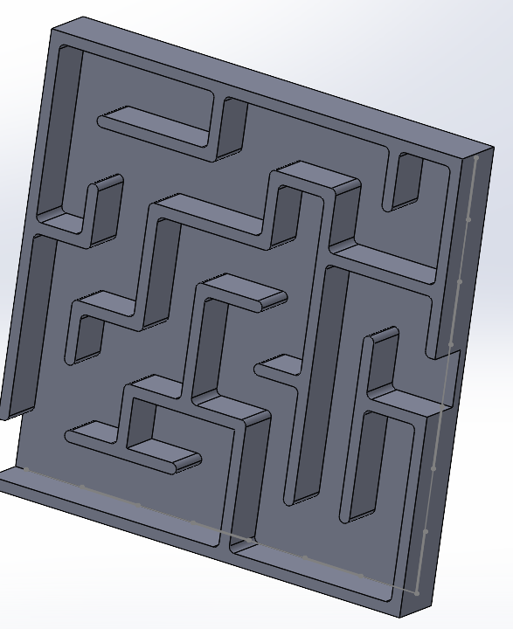

Designs Tested

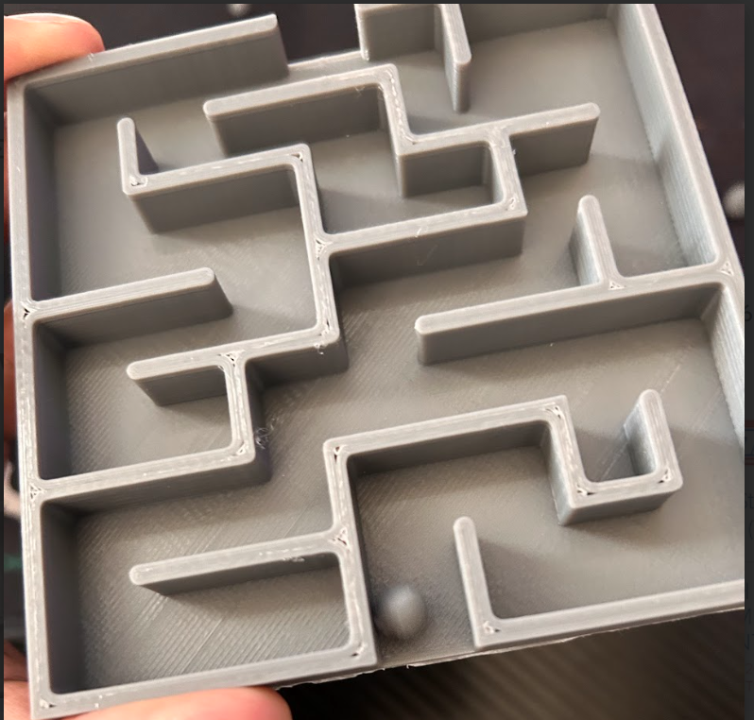
The photo above is the second maze of our 4-maze cube. We tested the maze multiple times with PLA plastic marbles ranging with diameters from 6mm to 12mm, and we have come to the conclusion that the 8mm marble was the best fit for this design (we will be using an actual metal marble instead of a 3D printed one). This change to the prototype completely beneficially changed the functionality and user-friendliness. We’d say one of the primary strengths of this prototype is that it is extremely user-friendly. It is very easy to control the marble, and pairing this with the fact that the mazes themselves are relatively moderate in difficulty, anyone, young or old, can play with this maze. However, one of our weaknesses for this prototype is that certain parts of the mazes were printed incorrectly, leading to some walls being shifted a few millimeters. This could lead to the maze being janky and uncomfortable at those parts.

Bill of Materials

Part | Quantity | Materials Used | Price of 1 | Total Cost | Item Purchase Cost (Amazon)
Acrylic covers | 4 | Acrylic | $2.83 | $11.32 | $17
Plywood covers | 4 | Plywood | $0.39 | $1.44 | $7
Metal Marble | 1 | Metal Ball bearing | $0.25 | $0.25 | $6.20
Maze parts | 4 | PLA plastic | $0.70 | $2.80 | $14
Maze cage | 1 | PLA plastic | $3.70 | $3.70 | [included with the cost above of $14]
Electronics cover | 1 | PLA plastic | $0.71 | $0.71 | [included with the cost above of $14]
Box cap | 1 | PLA plastic | $0.95 | $0.95 | [included with the cost above of $14]
Box cap lid | 1 | PLA plastic | $0.53 | $0.53 | [included with the cost above of $14]

Work Log
